A Smart Eyewear Reminder System Utilizing IoT and Cloud Technology

Tal Frank, Oren Lowte

Ben Gurion University

## **Abstract:**

**This paper introduces a novel solution aimed at addressing the common problem of forgetting to bring glasses when leaving home. The proposed system utilizes Internet of Things (IoT) technology, specifically ESP32 microcontrollers, along with cloud connectivity to provide timely reminders to users. By leveraging Wi-Fi connectivity, the system monitors the presence of glasses in the user's vicinity and sends notifications to their smartphone when they leave without their glasses. Additionally, the system collects data in the cloud to analyze user behavior and continuously improve the notification system. This paper outlines the design, implementation, and evaluation of the Smart Eyewear Reminder System, highlighting its potential to enhance daily life and improve user convenience.**

## **Keywords**

Wearable technology, IoT, Reminder systems, Smart Eyewear, User experience, Data analysis, Arduino, esp32.

Contents

**Abstract:** 1

**Keywords** 1

**Introduction:** 3

**Related Work:** 3

**System Design and Implementation** 4

**Functionality and User Experience** 6

**Data Collection and Analysis** 7

**Security Explanation** 8

**Future Directions and Conclusion** 9

**References** 10

## **Introduction:**

The act of leaving home without essential items is a common occurrence in daily life, often resulting in inconvenience and frustration. Among these forgotten items, eyeglasses hold particular significance for individuals who rely on them for vision correction. The inconvenience of forgetting glasses extends beyond mere inconvenience; it can affect productivity, safety, and overall well-being. To address this problem, we introduce the Smart Eyewear Reminder System, a novel solution leveraging Internet of Things (IoT) and cloud technology to enhance daily life.

many individuals do not wear their glasses in a day-to-day basis, but it is a necessity for clear vision for them. However, in the middle of the mess of daily life, it's all too easy to overlook grabbing one's glasses when leaving home. Whether rushing out the door to catch the next bus or simply navigating a busy schedule, the absence of glasses can lead to discomfort, impaired vision, and sometimes even safety concerns. The inconvenience of realizing one's mistake only after leaving home underscores the need for a proactive solution to address this common problem.

The Smart Eyewear Reminder System offers a proactive approach to reduce the risk of forgetting glasses when leaving home. By harnessing the power of IoT and cloud technology, the system provides users with real time reminders to retrieve their glasses before departing. At the heart of the system are two ESP32 microcontrollers: one embedded within the glasses case and the other serving as a transmitter we refer it as the base. These microcontrollers communicate wirelessly, monitoring the smartphone and sending notifications to the user mobile when necessary.

## **Related Work:**

There have been several studies that have explored the concept of utilizing location tracking for various projects. One of them introduces a system to find a better location in structural areas, as detailed in the article "Position Tracking Using Wi-Fi" by Dr. John Kapenga [6]. The problem the article tends to solve is the inaccuracy of GPS tracking inside structures. The article suggests using Wi-Fi to get a better approximation of the user’s location. In great similarity to our project, their system uses a central server that acts as a transmitter, establishing a communication line between the user and the other side of the system. Specifically, this article utilizes the system as an emergency line, where the user, if needed, can conveniently send a distress signal. This ensures that emergency forces who receive the message can find them at the best time and prevents unnecessary searching, saving crucial time in these situations. Although this article has a whole different idea at its inception, we found that the system's basic ideas to get the results are similar at most relevant points. That makes our idea unique by its purpose more than by its technology.

## **System Design and Implementation**

The Smart Eyewear Reminder System is built upon two ESP32 microcontrollers, strategically positioned to facilitate seamless communication and functionality. The first is ESP32 microcontroller is the base (*figure1*). acts as a transmitter and have an LCD screen, placed permanently in the house. This transmitter serves as the bridge between the glasses case and the user's smartphone, facilitating the delivery of timely reminders and the brain with the whole operation.

Figure 1 – The base, Esp32 with LCD screen

The second ESP32 microcontroller is housed within the glasses case (*figure 2*). serving as a sensor node responsible for detecting the presence of the glasses. Equipped with Wi-Fi capabilities, this microcontroller connects to the home network, enabling real-time communication with the cloud and the transmitter device.

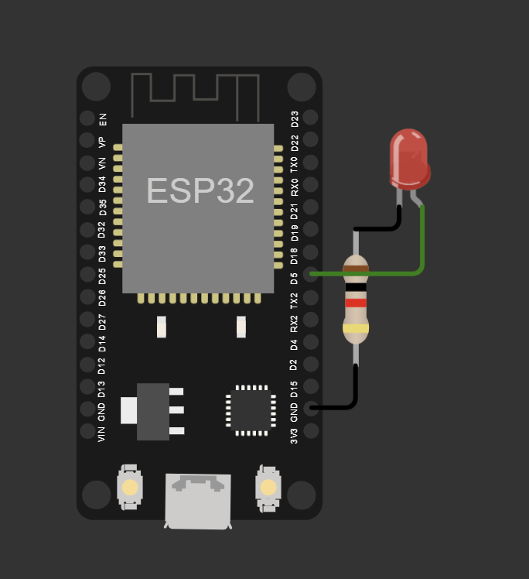

Figure 2 - sensor node responsible, Esp32 with light and battery

The software architecture of the Smart Eyewear Reminder System relies on a sophisticated blend of protocols and technologies to ensure seamless functionality. At its core, the system leverages Wi-Fi connectivity to enable communication between ESP32 microcontrollers and external devices. This connectivity enables the microcontrollers to establish robust communication channels, facilitating data exchange and transmission.

Central to the communication framework is the MQTT (Message Queuing Telemetry Transport) protocol, which efficiently delivers messages between the transmitter device and the user's smartphone. This lightweight protocol is particularly well-suited for IoT applications, where optimizing bandwidth and power consumption is paramount.

In addition to Wi-Fi and MQTT, the system integrates with AWS (Amazon Web Services) cloud infrastructure, providing a robust platform for data storage, analysis, and management. By leveraging AWS cloud services, the Smart Eyewear Reminder System gains scalability, reliability, and flexibility. User data is securely stored in the cloud, allowing for comprehensive analysis of usage patterns and continuous improvement of the reminder system over time.

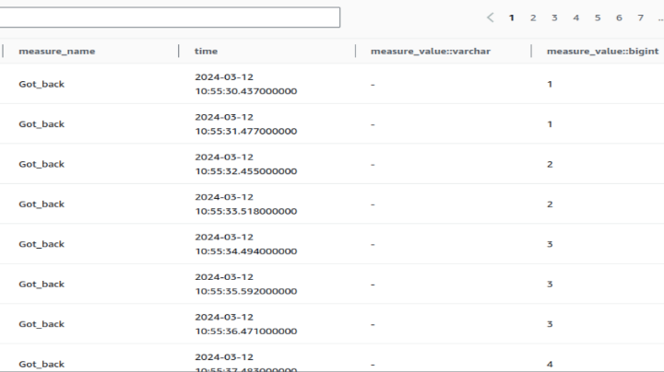

Table 1- Filtering the Time the User Comes Back for His Glasses

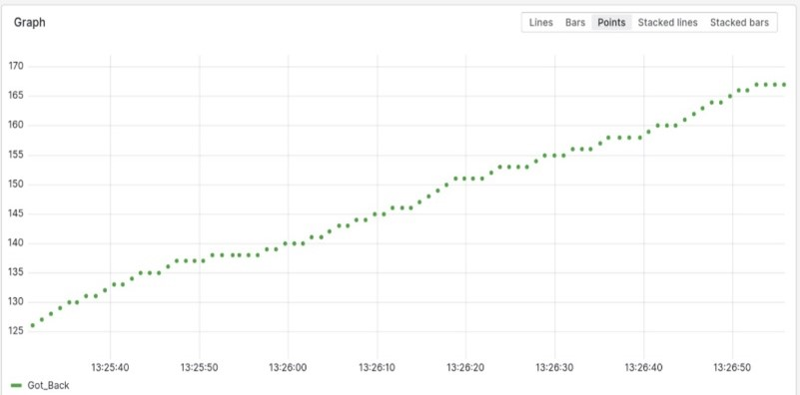

Graph 2 - Illustrating the Time the User Left and Returned Home Over Time

By combining robust hardware components with sophisticated software solutions, the Smart Eyewear Reminder System offers a comprehensive and effective solution to the common problem of forgetting glasses. The seamless integration of ESP32 microcontrollers, Wi-Fi connectivity, MQTT protocol, and AWS cloud services exemplifies the power of IoT and cloud technology to address real-world challenges and enhance daily life.

## **Functionality and User Experience**

The Smart Eyewear Reminder System employs a sophisticated detection mechanism to identify when the user has left home without their glasses. This process begins with the ESP32 microcontroller embedded within the glasses case, which is equipped with Wi-Fi connectivity, allowing it to communicate with the transmitter device and the cloud. As the user moves away from home, the microcontroller communicates with the transmitter. If the system determines that the user has left without their glasses, it triggers the notification system to send a reminder message to the user's smartphone.

The notification system plays a crucial role in reminding users to retrieve their glasses before leaving home. Upon detecting that the user has left without their glasses, the system initiates the notification process. Using the MQTT protocol, the transmitter sends a message to the user's smartphone, alerting them to the situation. The notification message is designed to be informative, concise, and attention-grabbing, alarming the user so they can decide whether to come back for the glasses. The message may include a personalized reminder such as "Don't forget your glasses!", a short and conclusive message to make it hard to miss by mistake.

The effectiveness of the notification system is evaluated based on user response and behavior. Through real-world testing and user feedback Figure 3, the system iteratively refines its notification strategy to maximize effectiveness and user engagement. In the future, it is possible to add a UI (User Interface) which will allow the user to specify specific times they want a reminder. For example, if a student has a lecture every Monday, Tuesday, and Thursday, they can cancel every other notification and set a reminder only on the days they actually need the glasses.

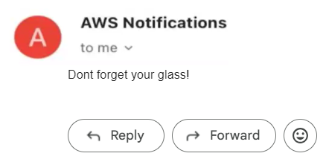

Figure 3 - Enhanced AWS Simulation for Email Notification on Device Disconnection

This diagram illustrates the orchestrated process within AWS for sending email notifications when two devices disconnect in the Smart Eyewear Reminder System. Through AWS IoT Core, Lambda functions, and Amazon SNS, the system ensures prompt alerts, enhancing reliability and user experience.

## **Data Collection and Analysis**

The Smart Eyewear Reminder System collects data points to evaluate its performance and effectiveness. One key dataset includes the connection status of the user's smartphone to the home Wi-Fi network, monitored by the transmitter ESP32 microcontroller. This data indicates when the user leaves home without their glasses, as the smartphone disconnects from the Wi-Fi network while the microcontroller in the glasses case remains connected. Additionally, the system collects user responses to the reminder notifications sent to their smartphone. This data provides insights into user behavior, such as the frequency of returning home for the glasses after receiving a reminder and the response time to notifications.

|  |  |  |
| --- | --- | --- |
| **Timestamp** | **Forgot Glasses** | **Came Back Home** |
| 2024-01-18 14:49:09 | TRUE | FALSE |
| 2024-03-28 13:09:02 | FALSE |  |
| 2024-02-15 06:13:38 | FALSE |  |
| 2024-01-27 09:50:24 | TRUE | TRUE |
| 2024-03-28 19:35:52 | TRUE | FALSE |
| 2024-03-11 19:53:12 | FALSE |  |
| 2024-03-20 19:21:04 | FALSE |  |
| 2024-04-04 06:43:54 | FALSE |  |
| 2024-01-31 22:06:02 | TRUE | TRUE |

Table 2 - Data from AWS which the base made

This data indicates whether the glasses were forgotten (TRUE or FALSE) and whether the user returned home after forgetting the glasses (TRUE or FALSE). This information can be further analyzed to understand patterns of forgetfulness and the effectiveness of the reminder system in prompting the user to return home for their glasses.

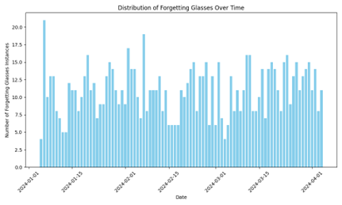

Figure 4 - Distribution of Forgotten Glasses Instances Over Time

This graph illustrates the analysis of glasses retrieval and response time trends over time in the Smart Eyewear Reminder System. The x-axis represents the timeline, showing dates over a specific period of time. The y-axis denotes the number of instances where users forgot to take their glasses and whether they returned home to retrieve them. Each data point on the graph corresponds to a specific date and reflects the frequency of forgotten glasses instances. Additionally, the graph may include trend lines or markers indicating the average response time for retrieving glasses after receiving the reminder notification. Analyzing these trends provides valuable insights into user behavior patterns and system performance dynamics, helping to refine the reminder system and enhance user experience.

The collected data is analyzed to assess the performance of the Smart Eyewear Reminder System. Metrics such as the accuracy of detecting forgotten glasses, the effectiveness of reminder notifications, and user engagement with the system are evaluated. For example, the analysis includes calculating the percentage of instances where users return for their glasses after receiving a reminder. The system detects when the user came back for their glasses by checking if a few minutes after the notification was sent to the user, they got connected back to the Wi-Fi. Additionally, the system tracks the time elapsed between receiving a reminder notification and the user's response. By quantifying these metrics, the system can critique its performance and identify areas for improvement.

The insights gained from data analysis inform decision-making and guide improvements to the reminder system. For instance, analysis may reveal patterns or trends in user behavior, such as certain times of day when users are more likely to forget their glasses. That kind of data can help the system send a reminder before the user even leaves home. Insights into user responses to notifications may highlight areas where the system can be optimized to enhance user engagement and effectiveness. This kind of data can help the system improve effectiveness and user experience in the future.

## **Security Explanation**

Ensuring the security of the Smart Eyewear Reminder System is paramount to safeguarding user data and maintaining privacy. One potential vulnerability to consider is the risk of unauthorized access to the system, particularly if the base station is tampered with or stolen. To mitigate this risk, robust security measures should be implemented at various levels of the system.

Firstly, access controls should be enforced to restrict unauthorized physical access to the base station. This may involve securing the physical location of the base station, such as using locks or access control mechanisms to prevent unauthorized individuals from tampering with the device. Additionally, the base station itself should be securely mounted or installed to deter theft or tampering.

Secondly, network security measures should be implemented to protect data transmission between the base station, cloud servers, and user devices. This includes encrypting data transmitted over Wi-Fi networks to prevent eavesdropping or interception by malicious actors. Strong encryption protocols and authentication mechanisms should be employed to ensure that only authorized devices can access and communicate with the system.

Furthermore, user authentication mechanisms should be implemented to control access to the system's mobile application or web interface. This may involve requiring users to authenticate themselves using secure login credentials, such as passwords or biometric authentication, before accessing the system's features or data.

Regular security audits and vulnerability assessments should also be conducted to identify and address any potential security weaknesses or vulnerabilities in the system. This proactive approach can help prevent security breaches and ensure that the Smart Eyewear Reminder System remains secure and resilient against evolving threats.

By implementing robust security measures at various levels of the system, the Smart Eyewear Reminder System can effectively protect user data, maintain privacy, and mitigate the risk of unauthorized access or tampering.

## **Future Directions and Conclusion**

While the Smart Eyewear Reminder System already offers valuable functionality, there are several potential enhancements and extensions that could further improve its effectiveness and user experience. One potential enhancement is to develop an app that allows the user to specify personal preferences, such as specific days of the week or hours of the day when they do not want to receive reminders. Another potential enhancement could be the integration of machine learning algorithms to personalize reminder notifications based on user behavior and preferences. By analyzing user interactions and response patterns, the system can tailor reminders to individual users, increasing their relevance and impact. Additionally, it is possible to create more smart trackers for other items people tend to forget, such as wallets, and enable them all to communicate with the same transmitter. This way, users can receive reminders for everything they might leave behind, not just their glasses.

In conclusion, the Smart Eyewear Reminder System has the potential to have a profound impact on improving daily life and enhancing user convenience. By addressing the problem of forgetting glasses, the system reduces frustration, discomfort, and inconvenience for users, allowing them to move through their day with confidence and clarity. Additionally, by leveraging IoT and cloud technology, the system offers a scalable and adaptable solution that can be customized to meet the needs of individual users. By addressing a common pain point with a practical and user-friendly solution, the Smart Eyewear Reminder System should alleviate stress when leaving home, knowing it will ensure that users do not forget anything important behind.

## **References**

[1] Wei, T., & Bell, S. (2012). Impact of indoor location information reliability on users. Lecture Notes in Computer Science, 7478, 258-269. doi: 10.1007/978-3-642-33024-7_19

[2] Redpin - indoor positioning for the rest of us. (2008). Retrieved from http://redpin.org/

[3] Thrun, S., Lookingbill, A., & Kadous, M. (2011, May 23). United States Patent: 8,583,400. Retrieved from http://patft.uspto.gov/netacgi/nphParser?Sect1=PTO2&Sect2=HITOFF&u=/netahtml/PTO/searchadv.htm&r=22&f=G&l=50&d=PTXT&p=1&p=1&S1=(indoor AND tracking)&OS=indoor AND tracking&RS=(indoor AND tracking)

[4] Sundararajan, A., & Lin, J. (2011, July 15). United States Patent: 8,589,318. Retrieved from http://patft.uspto.gov/netacgi/nphParser?Sect1=PTO2&Sect2=HITOFF&u=/netahtml/PTO/searchadv.htm&r=2&f=G&l=50&d=PTXT&p=1&p=1&S1=(indoor AND localization)&OS=indoor AND localization&RS=(indoor AND localization)

[5] Bickerstaff, R. (2011, February 25). United States Patent: 8,589,230. Retrieved from http://patft.uspto.gov/netacgi/nphParser?Sect1=PTO2&Sect2=HITOFF&u=/netahtml/PTO/searchadv.htm&r=2&f=G&l=50&d=PTXT&p=1&p=1&S1=(indoor AND localization)&OS=indoor AND localization&RS=(indoor AND localization)

[6] Kapenga, J. (Year of publication). Position Tracking Using Wi-Fi [Journal article]. Journal Name, Volume